

**UNIVERSITI TEKNOLOGI MALAYSIA**

**SCHOOL OF COMPUTING**

**SESSION 2020/2021 SEMESTER 1**

**SECV2113 - 07 HUMAN COMPUTER INTERACTION**

**PROJECT PART #1: PROJECT PROPOSAL**

**GROUP NAME: WALNUT**

**LECTURER: NOR ANITA FAIROS BINTI ISMAIL**

**GROUP MEMBER :**

|  |  |
| --- | --- |
| 1. NURSYAHIDATUL ASYIQIN BINTI YUSOF | A19EC0140 |
| 1. IRMA ZAFIRAH BINTI MOHD IKRAM | A19EC0054 |
| 1. IZZATUN NADIAH BINTI ABDUL RAHMAN | A19EC0056 |
| 1. NURUL SYAMIRA BINTI AMAT JIFRI | A19EC0145 |

**TABLE OF CONTENT**

**INTRODUCTION** **3**

**PROBLEM** **3**

**Problem Statement 1 (User experience problem)** **3**

**Problem Statement 2 (Usability problem)** **4**

**Problem Statement 3 (User experience problem)** **5**

**PROPOSED SOLUTION** **6**

**Solution for problem 1** **6**

**Solution for Problem 2** **6**

**Solution for Problem 3** **7**

**TARGET USERS** **8**

# INTRODUCTION

A project has been given on designing an interactive product based on the problem that is affecting the community. We had discussed the solution to those problems and we decided to design a super comfortable chair which can be used by the community at various ages. Therefore, we also observed that people need to work and study at home due to the pandemic issues. So, we had come up with the idea to make a chair that is comfortable for them to use it anytime and anywhere.

# PROBLEM

# Problem Statement 1 (User experience problem)

Living a sedentary lifestyle can be dangerous to human health. Sedentary lifestyles do affect the human body such as hips and back. In our research, people usually complain of having really bad pain in their back after sitting for long periods with a poor posture on the body. These problems become worse if they consistently sit with poor posture and the design of the chair is not ergonomically. Poor posture may also cause spine curvature which compel the natural curves to change shape because of putting an excessive amount of pressure in the wrong position. This poor posture will also cause others pains such as stiff neck and shoulders, headaches, and poor sleep. For example, in a university, students, lecturers and office workers are one of those people whose job requires them to sit for a longer time especially in our pandemic. Thus, they are more exposed to these pains compared with others.

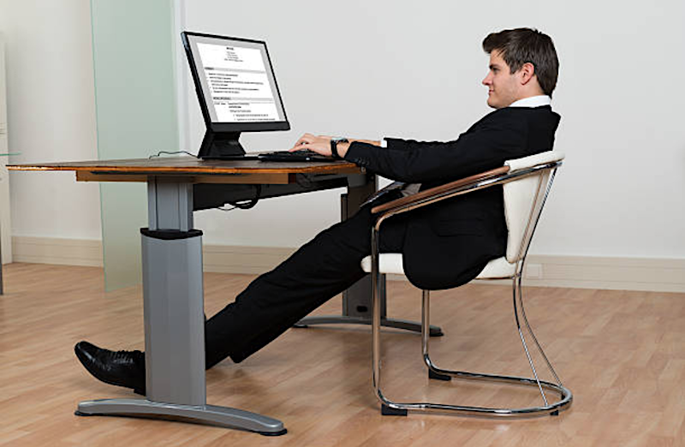

Figure 1: Bad posture while sit

# Problem Statement 2 (Usability problem)

Most people are working and studying while sitting on a comfortable chair and make their work easier. Sometimes, they need the comfortness somewhere other than their own room or space. However, their chair could not be brought anywhere or if could, the users need to have extra care and force as the chair is in its original shape. Usually, the chair is big in shape. Other than that, chairs in their original shape and design usually take up so much space in certain areas. To the students or the lecturers that are provided with limited area in their room, it would be a bit unbeneficial if their chair could not be stored easily.

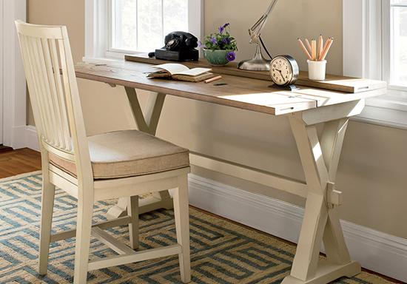

Figure 2: Unfoldable chair

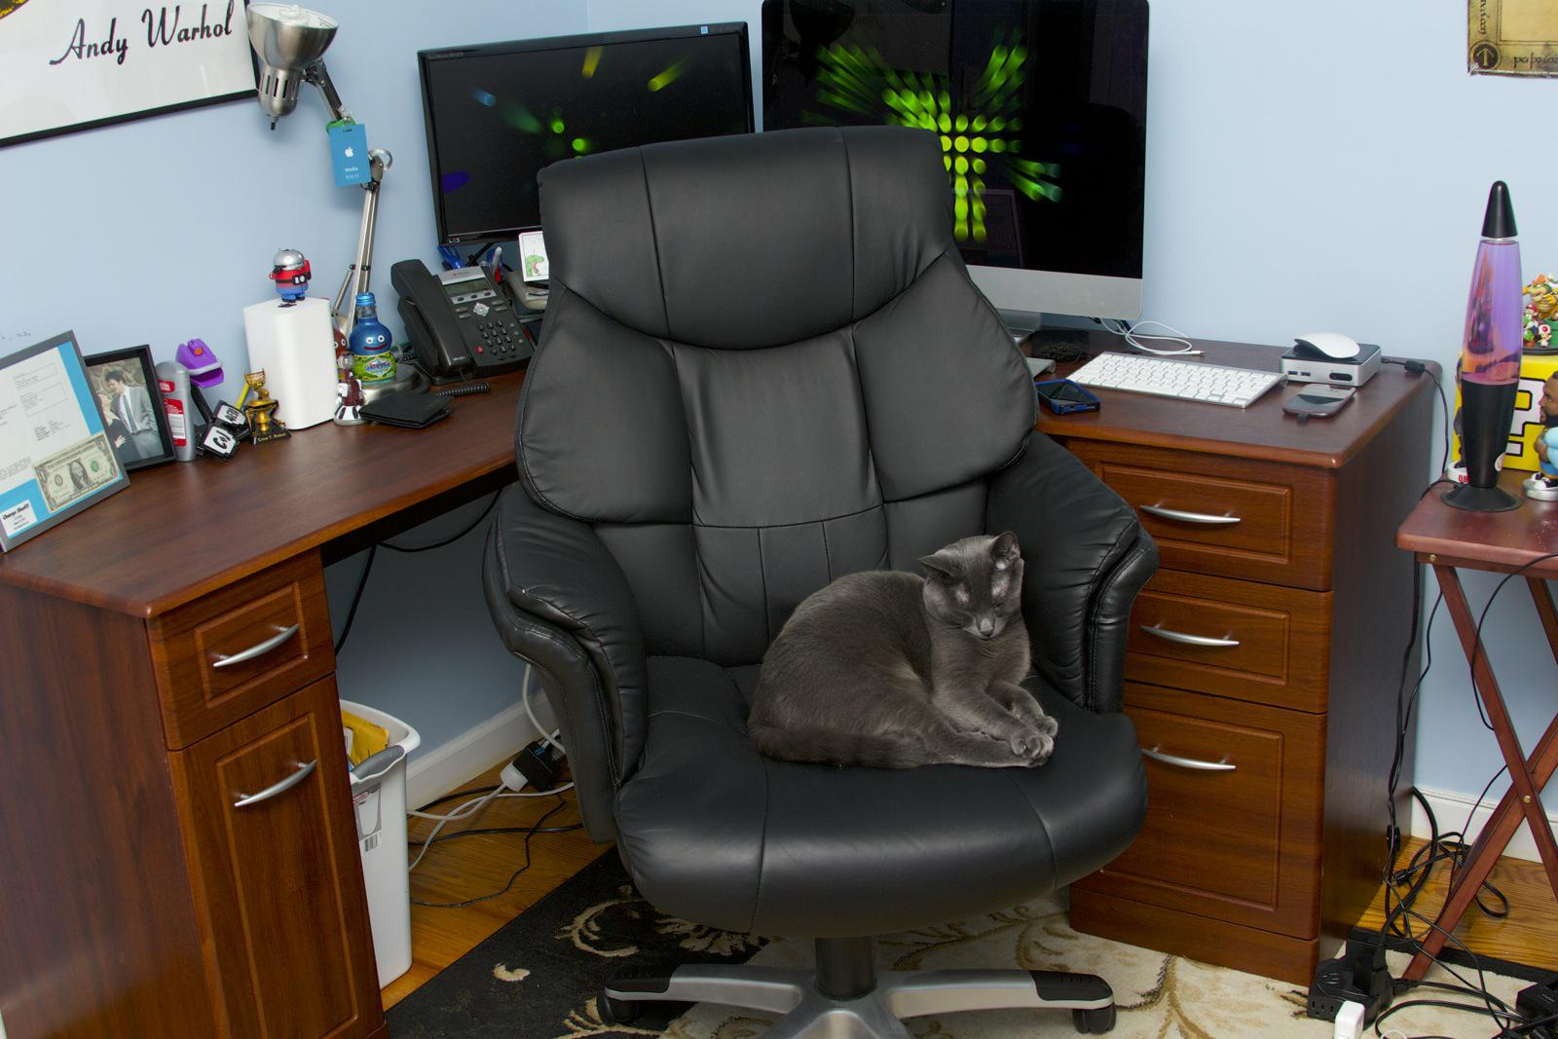

Figure 3: Chair takes up space

# 

# Problem Statement 3 (User experience problem)

Nowadays, using laptops or PCs has become our daily routines for various occasions especially for work and school. People would buy a whole desk in order to put their laptop, mug, stationery and notebook. Some chair designs have a fixed armrest meanwhile some do not. According to [Alison Heller-Ono](https://www.worksiteinternational.com/blog/author/alison-heller-ono) (2019), most employers aren’t buying chairs with fully adjustable armrests to fit even 50% of their workforce. So they remove them explaining why employees use chairs without them. If armrests are fixed in position or limited in height, width, and/or pivot, then they most assuredly won’t fit correctly and can’t be used properly by a majority of employees resulting in awkward side leaning or interference so often reported. When this happens, the most reasonable action is to remove them eliminating any possible benefits reported. In addition, adjustable chairs can change the height of their chair to allow users sit at the correct height to their desks by using a tilt adjustment underneath the chair. This depicts a little bit of hassle because they will have to adjust their seat to their desk in order to follow their comfort.

# PROPOSED SOLUTION

# Solution for problem 1

In designing such a product, understanding users' needs are important for a designer to make sure the product categories as a good design. Since the chair is regularly used by humans to sit, the design of it must support shoulder and back comfort. Hence to prevent from having a worse pain we designed a chair which the backrest of it can change based on people's back size. This chair will follow the user back and fit their size. We use the flexing material or springs in the chair shell which can come back to its normal shape later. Besides, The design of the chair is not straight as what we usually see but we make it curves which most likely similar to human backbones. The backrest angle also adjustability which allows the chair to support different degrees of recline. Since this feature only works if users have a good posture, therefore, we install a sensor motion which can detect the posture of the user. It then will have a minor vibration if the sitting posture was wrong. This sensor works similarly like a seatbelt sensor which is the most reliable way to detect if a seat belt has been engaged or not.

# 

# Solution for Problem 2

To come up with a solution for the second problem, we think of a portable comfortable chair. By portable, we meant a chair that will be convenient and easy to be brought anywhere. To be easily accessible, the shape of the chair will be reduced to a smaller size. Hence, we think of a foldable chair. When users can fold the chair, they can bring the chair to anywhere else to be able feel the same comfort while working on their task. For example, when students need to work on group tasks and decide to do at one student’s room. Other than that, a foldable chair can save some space when folded and be stored anywhere when they are not needed.

# Solution for Problem 3

To make an experience of using a chair more comfortable and accommodating, we have come up with a few features for this problem. Firstly, the chair could transform with a touch of a button. As stated in solution from problem 2, we want to make the chair portable and flexible. Secondly, there is a desk along with adjustable armrests that are attached to the chair where users could simply press a button to open up the desk and alter the armrests’ positions. On the sides of the desk, there would be a stationery holder and a cup holder. Therefore, there would be more space on the desk where users could put their laptop and for them to jot down notes on a book.

# 

# TARGET USERS

1. Student

This comfy chair is suitable for the student because most students spend their time sitting on the chair doing assignments. A cup handler is provided at this chair to avoid it spill on the table and paper. This can make them drink whenever they feel sleepy and tired from doing the assignment for too long without worrying about anything. So, it is very convenient for the student to use it during class or doing assignments.

1. Lecturer

The function of this comfy chair is very usable for the lecturers because it has a good design that can make them comfortably sit on them without having a backache. Since we are having a pandemic issue, all the lecturers need work from home and they need to teach using an online learning method, so they spend their time sitting in front of the computer.

1. Officer(Clerk)

All the officer workers must love this chair once they use it because it is foldable and portable. For example, a clerk that always spends their time in front of the computer doing letters and reports. Sometimes, their work cannot be finished at the office so they want to bring it home. They can also use this chair because it is foldable and can bring it anywhere.