

**UNIVERSITI TEKNOLOGI MALAYSIA**

**SCHOOL OF COMPUTING**

**SESSION 2020/2021 SEMESTER 1**

**SECV2113 - 07 HUMAN COMPUTER INTERACTION**

**PROJECT PART #3: CONCEPTUAL & PHYSICAL DESIGN**

**GROUP NAME: WALNUT**

**LECTURER: NOR ANITA FAIROS BINTI ISMAIL**

**GROUP MEMBER :**

|  |  |
| --- | --- |
| 1. NURSYAHIDATUL ASYIQIN BINTI YUSOF | A19EC0140 |
| 1. IRMA ZAFIRAH BINTI MOHD IKRAM | A19EC0054 |
| 1. IZZATUN NADIAH BINTI ABDUL RAHMAN | A19EC0056 |
| 1. NURUL SYAMIRA BINTI AMAT JIFRI | A19EC0145 |

1. **Interaction Metaphor**

|  |  |  |
| --- | --- | --- |
| NO. | ICON | DESCRIPTION |
| 1. |  | Power On/Off button - For the users to unfold and fold the chair. |
| 2.. |  | Setting - Use for users to adjust the application based on its preference and view or update their profile. |
| 3. |  | Adjust chair - For the user to make an adjustment at the backrest, armrest and desk. |
| 4. |  | Reading - It is an additional icon for the user to improve their knowledge and gain some information while relaxing. |
| 5. |  | Reminder - For the user to set up their own reminder for themselves. |
| 6. |  | Time tracker - For the user to view their duration of sitting on the chair for a day or a week or a month or a year. |
| 7. |  | Back - use for user to go back to the previous page in the application |

1. **Hand-sketching Storyboard**

Storyboard Task 1: View time tracker

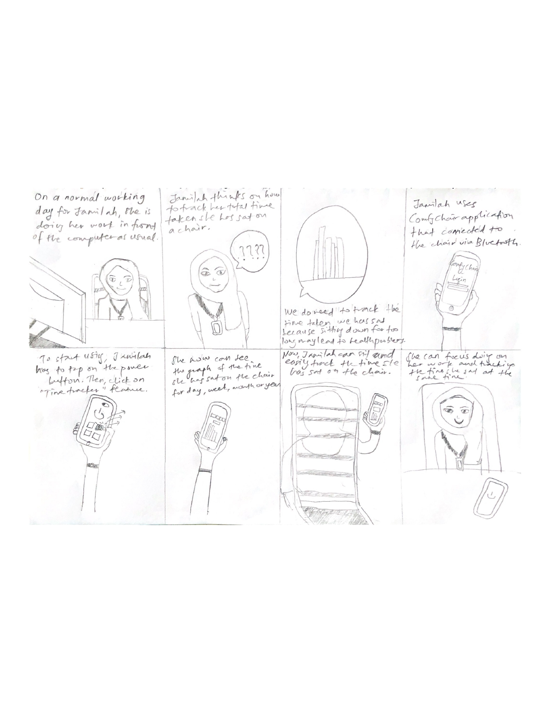

Storyboard Task 2: Being reminded (Reminder alert)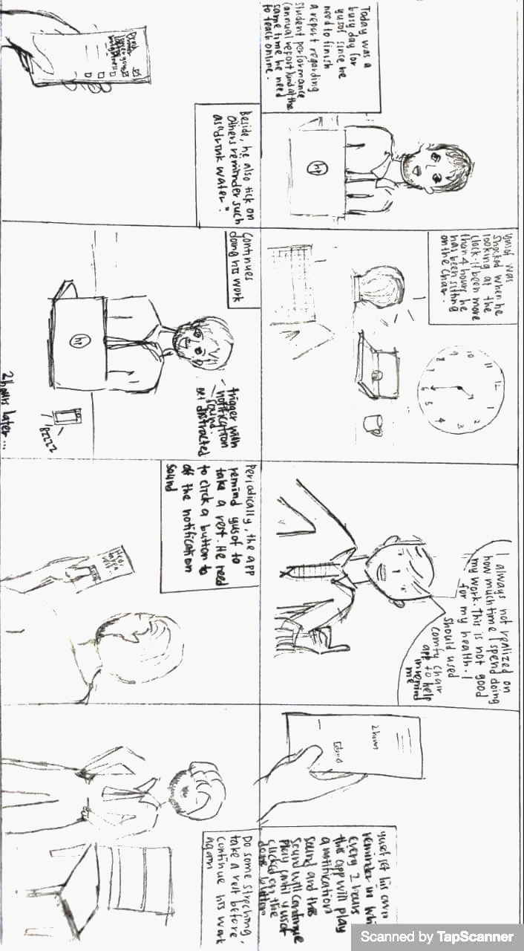

Storyboard Task 3: Unfold/Fold and Adjust chair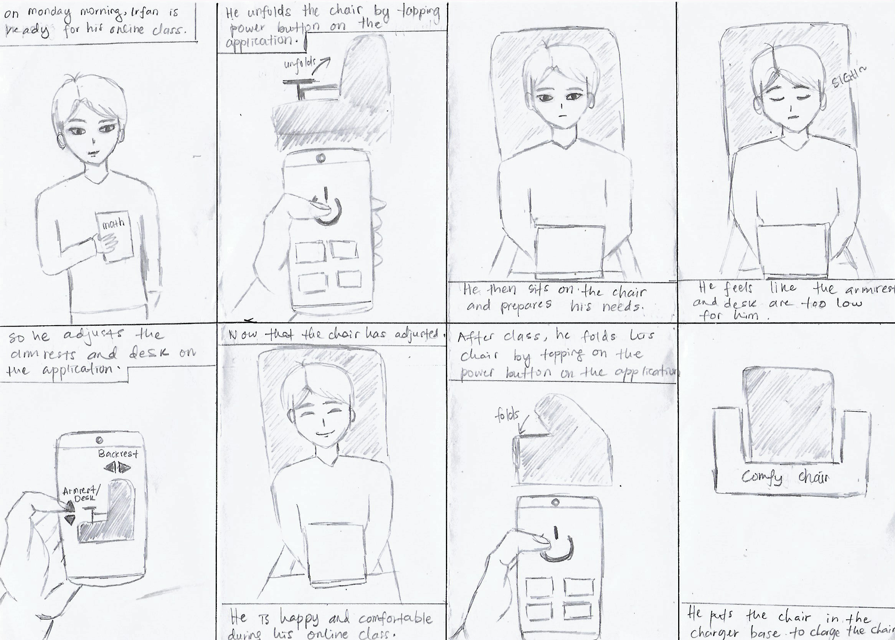

1. **Layout Screen Design - LFP**

Task 1: View Time Tracker

|  |  |  |
| --- | --- | --- |
| NO. | SCENE | DESCRIPTION |
| 1. |  | * Our application “Comfy Chair” first page whenever a user clicks on the Comfy Chair icon on their phone’s home screen. * User can login to the app if they already have an account. User can choose their preferable method to login; email and password, Google or Facebook. |
| 2. |  | * For a new user, they can sign up to create an account for the app. Also, they can choose their preferable method to sign up. |
| 3. |  | * This is the main page of the Comfy Chair app. * There are features on the main page for the user to choose what they are going to do; **Adjust chair, Time tracker, Reminder** and **Reading.** |
| 4. |  | * User have to click on the **Connect to chair** to connect the functions on the app with the chair via Bluetooth. * If it is not connected, users could not click on the features provided. |
| 5. |  | * This is how the main page looks like after it is connected and enables users to use the features. |
| 6. |  | ***Time tracker***   * User clicks on **Time tracker** feature |
| 7. |  | * After the user clicks on the Time **tracker** feature, they will be headed to the total time taken the user has sat on the chair. * Users can click on the top of the page which time period they want to track. * On the first page **‘Day’**, the total time recorded is for the day. |
| 8. |  | * On the second page **‘Week’**, the total time recorded is for the week. |
| 9. |  | * On the third page **‘Month’**, the total time recorded is for the month. |
| 10. |  | * On the fourth page **‘Year’**, the total time recorded is for the year. |

Task 2: Being reminded (Reminder alert)

|  |  |  |
| --- | --- | --- |
| NO. | SCENE | DESCRIPTION |
| 1. |  | ***Reminder alert***   * User clicks on the reminder feature. |
| 2. |  | * This is the reminder feature page. * There are a few reminders provided by the application. * However, a user can add their own reminder by tapping on the “plus” button. * A user can check the box to mark the reminder as finished. |
| 3. |  | * Here is where a user can write their own reminder. * A user can set the date, time and alarm alert. * After setting up a reminder, a user taps the button “Save” to store the reminder. * A user also can tap the button “Cancel” if they change their mind. |
| 4. |  | * This alert pops out at a particular time in which the user has set it up. * Tap the button “Close” to turn off the alert. |

Task 3: Unfold/Fold and Adjust chair

|  |  |  |
| --- | --- | --- |
| NO. | SCENE | DESCRIPTION |
| 1. |  | * This is the main page after a user connects the application to the chair via bluetooth. * It is also the page before a user unfolds the chair. * A user is not allowed to use any features before pressing on the power button. |
| 2. |  | * This happens when a user unfolds the chair by tapping on the power button. The colour green on the button indicates that the user is unfolding the chair. * A user is now allowed to use the features. |
| 3. |  | ***Adjust chair***   * User clicks on Adjust chair feature |
| 4. |  | * This is the page for the adjust chair feature where a user can adjust their chair. |
| 5. |  | * This happens when a user uses the “up” button to raise their desk/armrest |
| 6. |  | * This happens when a user uses the “down” button to lower their desk/armrest |

1. **Justification of the Layout Screen Design based on Gestalt and Shneiderman’s Golden Rules**

**Similarity (Gestalt Principle)**

On the main page, each icon has a different image where each image must relate to its task. These icons are similar in shape, style and colour. The structure of the shape is square and it is surrounded by the green line. Beside, each icon has a text underneath in order to inform the user on what exactly the elements are for.

**Consistency (Shneiderman’s Eight Golden Rules)**

Everytime a user clicks on any icon, it will turn the background to dark green as to show the difference to the user that he or she had clicked on those certain icons . This design is applied to all the icons.

**Enclosure (Gestalt Principle)**

In task 2, each reminder is separate with the green boundary line around them. Each of the reminders group consist of its description and mark box. This design clearly helps users to differentiate every reminder because the design looks efficient and well organized. Thus, the users can add numerous reminders on their own. Even though each reminder is separated with boundary but it still can be seen as one when they are grouped together.

**Continuation (Gestalt Principle)**

On the viewing time tracker task, there is an orange vertical bar graph shown for each time they want to view. The orange vertical bar shows how many they had been sitting for a day, a week, a month and a year. This will be easier for the user to monitor their time of sitting. The continuous flow of the orange vertical bar attracts the user’s eye to look at it because of the striking colour and the visual.

**Simple error handling (Shneiderman’s Eight Golden Rules)**

On each task, there is a back button for the user to go back to the main page. This back button was made for the user if they click any other button on the main page and they want to return to the main page. This helps the user to easily go back to the main page and to start over. It is just a simple instruction for the user to understand easily.

**Reduce short-term memory load (Shneiderman’s Eight Golden Rules)**

Since the design for each task was very simple and easy to understand this will help users to recall faster on what to do for each task. As there was a statistic about humans which we are only capable of retaining 5 items in our short term memory at one time therefore this is why we only have 4 designs in our main menu page.